

TEAM MULTI-ACADEMY TRUST

Updated September 2023
Devon

Life, Love and Learning to the Full (Vision)

Providing the children of North Devon with a World Class Education (Mission)

Children at the centre of all decision making

Building Learning Power (Wisdom and Excellence)
Building Futures (Aspiration and Hope)
Building Community (Serving and Caring for Others)
Building Self-Esteem & Positive Mental Wellbeing (Compassion and Enjoyment)

Purpose & Direction,
Curriculum & Assessment, Teaching & Learning, Developing the Organisation,
Facing Outwards, Finance, EYFS

Curriculum Plan
Intent
At TEAM Multi-Academy Trust, we aim to build the foundations of life in all its fullness underpinned by our school values, where we understand what it means to be loved and to love others within our school and our local, national and global community. To achieve this, we have created a curriculum built on four drivers: Building Learning Power, Building Communities, Building Self-Esteem and Building Futures. It is through our drivers that we seek to raise children's personal aspirations by providing them with the skills, knowledge and understanding to realise their ambitions. Through our ‘Big Event’ curriculum, all children have a wide range of experiences that broadens their horizons and deepens their learning. The curriculum provides opportunities for the children to develop a sense of pride in their locality whilst at the same time helping them to learn about other cultures from around the world. Our curriculum is rich, exciting and diverse, but most importantly, it is accessible to all because we ensure that all children have the skills they need to engage with their learning at every level.

Implementation
The learning journey is mapped out year by year; subject-specific content ensures there is clear progression, consolidation and extension of skills and knowledge. Knowledge Rich Projects (KRPs) and Imaginative Learning Projects (ILPs) provide exciting learning activities across all subjects. The approach we take is based on the following four key components of learning:
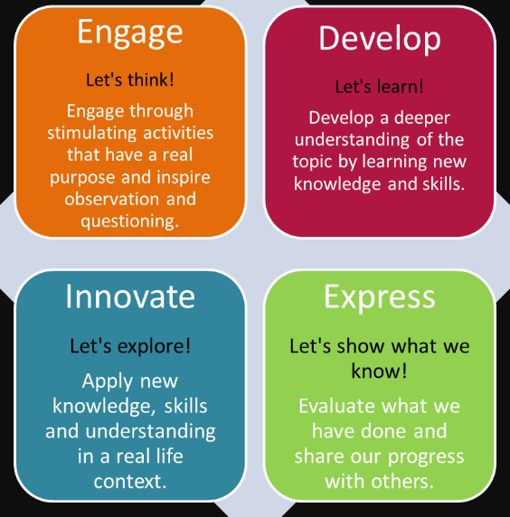



Nolans
Principles

Committed

Confident

Curious

Challenging

Collaborative

Critical

Creative
All those on the LGB should fulfil their duties in line with the seven principles of public life.

Committed
Devoting the required time and energy to the role and ambitious to achieve best possible outcomes for young people. Prepared to give time, skills and knowledge to developing themselves and others in order to create highly effective governance.

Confident
Of an independent mind, able to lead and contribute to courageous conversations, to express their opinion and to play an active role on the board.

Curious
Possessing an enquiring mind and an analytical approach and understanding the value of meaningful questioning.

Challenging
Providing appropriate challenge to the status quo, not taking information or data at face value and always driving for improvement.

Collaborative
Prepared to listen to and work in partnership with others and understanding the importance of building strong working relationships within the board and with executive leaders, staff, parents and carers, pupils/students, the local community and employers.

Critical
Understanding the value of critical friendship which enables both challenge and support, and self-reflective, pursing learning and development opportunities to improve their own and whole board effectiveness.
Creative
Able to challenge conventional wisdom and be open-minded about new approaches to problem-solving; recognising the value of innovation and creative thinking to organisational development and success.

NOLAN’S PRINCIPLES
TEAM Multi-Academy Trust – Local Governing Body
- Each school within the Trust has its own Local Governing Body (LGB) which is a committee group of the Trustees. LGBs have the governance functions delegated to them by the Trust Board for their school and are accountable to the Board.
- The Local Governing Body is held to account for the performance of the school by the Board of Trustees.
- The LGB meet once termly with additional meetings being held as required.
- Meeting minutes to be sent to the Board of Trustees.
Responsibilities Include:
- Holding the Head of School to account for the performance of the school.
- Supporting the Strategic development of the school.
- Monitoring the school’s performance against the School Improvement Plan.
TEAM Terms of Reference for LGB’s
- Receive updates from Head of School (including staffing update, professional development).
- Review any key data – pupil numbers, staffing, exclusions etc.
- Review/monitor attendance and set attendance targets.
- Monitor curriculum-reports from curriculum leaders, school visitors, governor visit reports.
- Annual meeting with school council (Summer term).
- Review PSHE/RSHE policies.
- Review off-site activities/ extra-curricular activities.
- Review school meals provision.
- Monitor Early Years Provision and marketing of facilities.
- Review school prospectus and information available on website/within school & community.
- Monitor use and deployment of pupil premium and sports funding.
- Ensure strong community links.
The LGB shall have the following members: (Information taken from updated Terms of Reference (2023)
- No less than 5 members.
- The Head of School on an ex-officio basis.
- The Chair may not be an employee of TEAM MAT and should be elected annually.
- At least two Parent Governors. These may be elected or be Trustees of the board.
- In the case of Pilton Bluecoat LGB the majority of the members must be members of the local Church Community.
- In the case of High Bickington and Witheridge LGBs at least two members must be members of the local Church Community.
- All persons appointed or elected to the LGB shall give a written undertaking to the Directors to uphold the Objects of the Trust (Code of Conduct).
- The quorum for each meeting will be three.
The Role of the Academy Head of School
The Academy Head of School is responsible for the day to day management of the academy and is managed by the CEO, but reports to the LGB on matters which have been delegated to the LGB. The Head of School will ensure their academies meet development plan targets and contribute effectively to achieving Trust priorities set by the Board.

Local Governing Body – Scheme of Delegation
2.0 | Governance Systems and Structures
2.7 | Identify governor training needs through the completion of Bluesky self-reviews
2.9 | Annual self- review of LGB performance
2.10 | Chair’s performance: carry out 360 review periodically
2.11 | Succession planning at LGB level
2.13 | Establish LGB working groups/subcommittees
3.0 | Reporting
3.3 | Register of all interests, business, pecuniary for members/trustees/governors/Portfolio Group members/senior employees: establish and publish annually
3.7 | Annual report of work of LGB: submit to trust
 | Discuss Head of School’s report and ask questions on pupil/school performance data
 | Safeguarding visit reports
 | Review outcomes from the IAAR Individual School Reviews
4.0 | Strategic
4.4 | Determine school level policies (see policy review schedule): approved by LGB, written and recommended by Head & SLT
4.5 | Monitor impact of Collective Worship
4.6 | Ensure that the teaching of religious education is effective
4.7 | Engagement with stakeholders
4.9 | Review Academy’s vision and strategy
5.0 | Academy Educational Performance, Curriculum & Teaching
5.2 | Monitor within academy: academic performance, the quality of provision and the quality of care  - Review school website  - Monitor pupil attendance figures  - Monitor academic data  - Monitor provision for the most vulnerable pupils.
5.3 | Consider and evaluate school performance against Key performance indicators set by the Trust and have oversight of curriculum, standards and outcomes
5.5 | Set, agree and monitor pupil level targets
5.6 | School one year school development plan (SDP) & SEF: approve and monitor  - Decide on a schedule for governor visits that are linked to the school improvement plan
5.7 | Approve and monitor curriculum plan
 | Review curriculum statement provided by the Head of School defining how subjects will be taught, evaluated and resourced.
5.10 | SIAMS – academy level monitoring of local framework & Christian distinctiveness in church schools
6.0 | Financial Governance & Management
6.10 | School Year to Date reports/budgets to review and monitor
6.19 | Report on Risks to Board, provide Risk Register in agreed format. Monitor risks and develop appropriate risk management strategies
6.20 | To review Asset Management Plan
8.0 | Staff and Performance Management
8.9 | Monitor performance management process of teachers and TA’s
 | Designated LGB governor to ensure Support Plans for SEN are in place and how the school intends to support the group.
 | Agree pupil premium/sports funding funding plans
 | Ensure safeguarding procedures are secure in schools
9.0 | School Policy and Procedures
9.6 | Attendance Policy & Plan
9.7 | Pupil Behaviour Policy (including exclusions)
9.8 | Monitor implementation of behaviour policies
10 | Inclusion and Equality
10.2 | Designate a governor to be responsible for monitoring SEN, Looked After children and Pupil Premium
10.3 | Monitor and evaluate the impact of Pupil Premium and Sports Grant funding and report to trust board
10.5 | Establish & publish annual “Equality information & objectives statement” and review objectives every 4 years. Academy objectives /action plan reviewed by LGB
10.6 | Establish an Accessibility Plan, for review every 3 years
10.7 | Ensure safeguarding procedures are secure in schools
 | Premises, Health & Safety
11.2 | Academy asset management plan – review

Competency Framework for Governance
Effective governance provides strategic direction and control to schools, academies and Multi-Academy Trusts (MATs). It creates robust accountability, oversight and assurance for their educational and financial performance and is ambitious for all children and young people to achieve the very best outcomes.
TEAM Multi-Academy Trust Governor Standards
Every year we ask our Trustees and Local Governing Body to review themselves on BlueSky for Education using the NGA Governor Standards.
Essential for all governors and trustees | I have a commitment to improving education for all pupils
Essential for all governors and trustees | I am able to work in a team and take collective responsibility for decisions
Essential for all governors and trustees | I have a willingness to learn
Essential for all governors and trustees | I am committed to the school’s vision and ethos
Essential for all governors and trustees | I have basic literacy and numeracy skills
Essential for all governors and trustees | I have basic IT skills (i.e. word processing and email)
Understanding and experience  of governance | I have previous experience of being a board member in another sector or a governor/trustee in another school
Understanding and experience  of governance | I have experience of chairing a board/governing board or committee
Understanding and experience  of governance | I have experience of professional leadership
Vision and strategic planning | I have an understanding and experience of strategic planning
Vision and strategic planning | I have the ability to analyse and review complex issues objectively
Vision and strategic planning | I have the ability to identify problems
Vision and strategic planning | I have the ability to propose and consider innovative solutions
Vision and strategic planning | I am experienced in reviewing the impact of new ideas and initiatives
Vision and strategic planning | I have the ability to learn from failure
Vision and strategic planning | I have the ability to make difficult decisions in the best interests of pupils
Vision and strategic planning | Change management (e.g. overseeing a merger or an organisational restructure, changing careers)
Vision and strategic planning | I understand current education policy
Holding the Head to account | I have communication skills, including being able to discuss sensitive issues tactfully
Holding the Head to account | I have an ability to analyse data
Holding the Head to account | I have the ability to question and challenge
Holding the Head to account | I have experience of project management
Holding the Head to account | I am able to performance manage/appraise someone else
Holding the Head to account | I have experience of being performance managed/appraised myself
Financial  Oversight | I am able to financial plan/manage (e.g. as part of your job)
Financial  Oversight | I have experience of procurement/purchasing
Financial  Oversight | I have experience of premises and facilities management
Knowing your school and community | I have links with the community
Knowing your school and community | I have links with local businesses
Knowing your school and community | I have knowledge of the local/regional economy
Knowing your school and community | I work or volunteer with young people (e.g. teaching/social work/youth work/sports coaching/health services for young people)
Knowing your school and community | I have an understanding of special educational needs
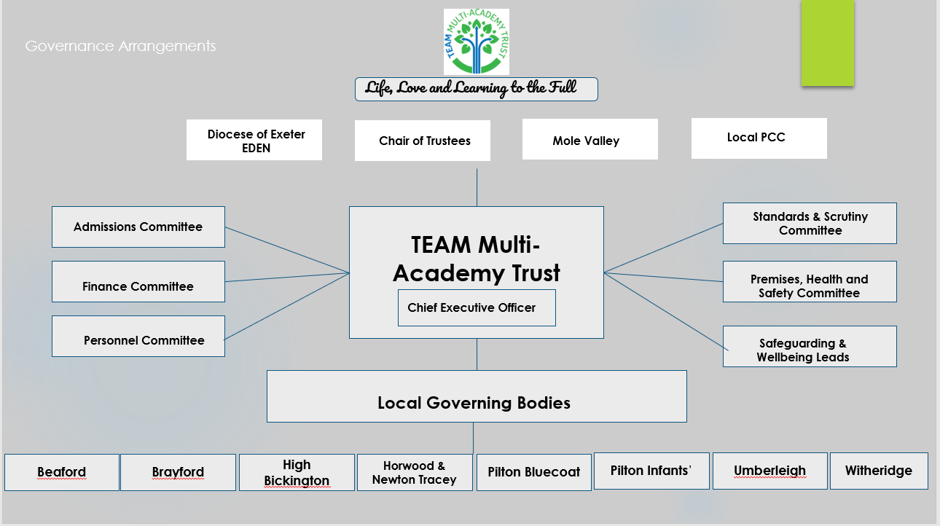

Academic Year 2023 to 2024
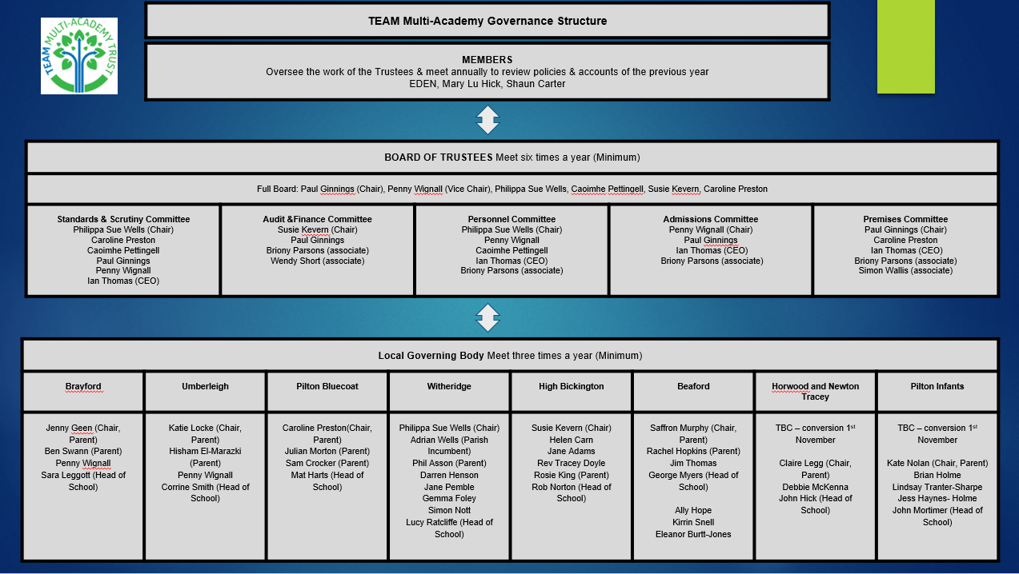
Appendix 1 – Heads Report Format
Life, Love and Learning to the Full
Head of School’s Summary
The intention of this report is to provide a Trust-wide overview of pertinent developments that have taken place since the last meeting which was held in July 2022.

Purpose of report:
- To assist the governors in making informed decisions that will impact on the success of the school and
strategic allocation of resources
- To provide a mechanism by which the Head of School can update the governing body on whole school
performance and the impact of the school improvement process.
- To provide information to ensure governors can provide well informed challenge and ask questions about
school performance, progress and future development priorities.

Leadership and Management
Contextual Information
Pupil Numbers for the Term:

SEND Register | Pupil Premium
Overall number on the register:
Number of EHCP’s

Looked After Children/Adopted | EAL

Attendance
Overall school attendance
Attendance of PP
Attendance of SEN
Notes:

Exclusions
Fixed Term
Permanent
Notes:

Safeguarding
Number of children on child protection
Number of children on Child in Need
Number of children on Early Help
Notes:

Staffing

School Improvement

Community Links

Updates on Pupil Premium and Sports Funding Initiatives

Policies & Other Key Documents

Quality of Education

Behaviour and Attitudes

Personal Development

Leadership and Management
Quality of the Early Years

Presenting the Data to the LGB – A note to Heads of School and Local Governors.
Along with the Head of School Report to Local Governors, Heads of School should also provide them with the key data headlines for reading, writing and maths. For the LGB meeting in taking place in the Autumn LGB members should receive a breakdown of the summer term data. For the meeting taking place in the spring a data should be presented for the Autumn term. The summer term meeting should data should be provided for the spring term.

Heads of School should ensure that LGB members have a good understanding of how many children are working at age related expectations for reading, writing and maths in each year group. They should also know how many of those children have reading, writing and maths combined. When presenting the data percentages will need to included for the whole class, males, females, SEN, EHCP, Pupil Premium, EAL and Looked After Children.

Phonics data should also be discussed.

Local Governors need to know in the Autumn and Spring how many children are on track to reach age related expectations in the DfE Key Stage Two SATs tests at the end of the year.

When the data is presented Local Governors will need to find out what the school is doing to ensure that those children who are behind catch up. A governor visit may need to be arranged during the Autumn and Spring to spend quality time looking at this.

Appendix 2 – Governor Visit Report format

TEAM Multi-Academy Trust
Governor Visit Form
Governor’s name: | Date of visit:  Wednesday 17th November | Classes visited:
Focus of visit:
Standards and Scrutiny committee visit
- Head of school presentations discussing outcomes of their SWOT analysis
- Focus on the subject leadership of Writing, History and Art.
- History work scrutiny focusing on the use of timelines/chronology and the acquisition of knowledge.
- Pupil voice work – what do the children know and say about History?
Sources of information:
e.g.: Headteacher, class teacher, display work, children’s workbooks, talking to children, looking at resources

Session 1: Head of School Presentations
General comments:

Summary of what was learned:

Session 2: Subject Leader Presentations on Writing and History
General comments:

Summary of what was learned:

Session 3: Work scrutiny of History
General comments:

Summary of what was learned:

Session 4: Pupil Voice Work - History
General comments:

Summary of what was learned:

Thank you so much for attending the day. We all very much appreciate and value the great work you do in ensuring our schools continue to flourish.

